A case study to evaluate a role of Mahatikta Ghrutpaan in management of Vicharchika

Baban Rathod¹, Sachin Sheth² , Ankita Apte ³

1. Professor and H.O.D., P.G Dept. of Rasashastra, APM’s Ayurved Mahavidyalaya, Sion, Mumbai, Maharashtra, India
2. Assistant Professor, P.G Dept. of Rasashastra, APM’s Ayurved Mahavidyalaya, Sion, Mumbai, Maharashtra, India
3. P. G. Scholar , Dept. of Rasashastra, APM’s Ayurved Mahavidyalaya, Sion, Mumbai, Maharashtra, India

ABSTRACT
Ayurveda is the oldest surviving complete medical system in the world. In Ayurveda system of medicine numbers of drugs /preparation are mentioned. Various herbal drugs and Herbo-mineral act as a rejuvenator for skin. Kushtha is among the wide spread chronic, frequently re occurring diseases of the skin. In the present era skin diseases are difficult to treat and are of high cosmetic value. In Ayurveda all skin diseases are consider under Kushtha. All the skin diseases in Ayurveda have been discussed under the broad heading of Kushtha, which are further divided in Mahakushtha and Kshudrakushtha. This paper highlights a case study of Vicharchika kushtha treated with Mahatikta ghrutpaan.

Key words:
Kushtha, Mahatikta ghrutpaan, Mahakushtha, Kshudrakushtha

Introduction:
In Ayurveda, almost all skin disease can be taken under generalized term “Kushtha”. Vicharchika is one of the Kshudrakushta having the Lakshanas like Shyava, Kina, Kharasparsha, Parusha. Rukshapidika and Kandu. Vicharchika kushta manifests due to vitiation of Saptadhatus like three Dosha, Twak, Rakta, Mamsa and Lasika. Vicharchika kushta is having involvement of Vata and Kaphadosha having the Lakshanas of individual Doshas, in this article management of Vicharchika kushtha is done with Mahatiktaghrutpaan.

Aim:
To evaluate the efficacy of Mahatikta ghrut in the management of Vicharchika
Objectives:
- Literary study of kustha
- Literary study of Vicharchika
- Literary study of Mahatikta ghrut

Materials and Methods:
15ml of mahatikta ghrut was given orally with lukewarm water early morning with empty stomach everyday for consecutive 30days.

Case study:
Name of Patient | XYZ
Age | 33yrs
Sex | Female
Height | 5.2ft
Weight | 68yrs
Prakruti | Kafa pittanubandhi
Lakshan | Itching, redness, burning
Chronicity | Since 12yrs
Intensity of pain | No pain
Hetu | Stale food, Frequent intake of meat
Sadhyasadhyatva | Sadhya
Plan of treatment | 15ml of mahatiktaghrut was given to the patient everyday in early morning &empty stomach with warm water.
Pathya | Rock salt, Ghee, Bitter guard, Elephant yam, Plantains, Green gram, Ginger, Boiled vegetables, Buttermilk
Apathya | Chillies, Tamarind, Excess salt, Curd, Paneer, Cheeze, Fermented food, Cold water

Criteria for assessment:
Subjective criteria:-
- Intensity of itching
- Intensity of burning
Objective criteria:-
- Redness
- Size of patch
Observation:
Characteristics | Before treatment | After treatment
Itching | +++ | Nil
Burning | +++ | Nil
Redness | +++ | Nil
Size of patch | 22cmX 9cm | No patch noted

Discussion:
According to Shabdkalpadruma, Kushtha means which causes Despise and contemptible.
According to Shabdkalpadruma, the word meaning of kitibha is kesa keeta.
In Ashtang hrudayam, kushtha chikitsa adhyay acharya vagbhat has stated that
कुष्ठिनं स्नेहपानेन पूर्वं सर्वमुपाचरेत् ।
- ह्र. चि. १९/१
That means in all skin diseases one must give ghrutpaan before starting any treatment.

In charak samhita, kushtha chikitsa adhyay, acharya has stated that

वातोत्तरेषु सर्पिर्वमनं श्लेष्मोत्तरेषु कुष्ठेषु ।
पित्तोत्तरेषु मोक्षो रक्तस्य विरेचनं चाग्रम् ।।
च.चि. ७/९२
That means in vatapradhan kushthas snehapaan, in kapha pradhan kushthas vaman karma, in pitta pradhan kushthas virechan karma followed by raktamokshan should be done.

Acharya charak has explained about Vicharchika kushtha,
(1)It is blackish brown in colour;
(2)It is rough in touch like a scar tissue
(3)It is hard to touch³
Dark patches on skin, dryness of skin, roughness on the patches are the symptoms of Vicharchika kushtha.

Using these two references, Snehpaan was selected as a treatment in present case.

Sharandhar samhita, acharya has described Mahatikta ghrut in madhyam khand.
सप्तछ्द: प्रतिविषा शम्याक: कटुरोहिणी ।
पाठा मुस्तमुशीरं च त्रिफला पर्पटस्तथा ।।
पटोलनिम्बमत्रत्रत्र्जिष्ठा पिप्पली पद्मकं शठी ।
चन्दनं धन्वयासश्च विशाले द्वे निशे तथा ।।
गुडुची सारिवे द्वे च मुर्वा वासा शतावरी ।
त्रायन्तीन्द्रयवा यष्टी भुनिम्बश्चाक्षभागिका ।।
घ्रुतं चतुर्गुणं दद्याद् घ्रुतादामलकीरस: ।
द्विगुण: सर्पिश्चात्र जनमष्टगुणं भवेत् ।।
तत्सिद्धं पाययेत् सर्पिर्वातरक्तेषु सर्वथा ।
कुष्ठानि रक्तपित्तं च रक्तार्शांसि च पाण्डुताम् ।।
ह्रुद्रोगगुल्मवीसर्पप्रदरं गण्डमालिकाम् ।
क्षुद्ररोगान् ज्वरांश्चैव महातिक्तमिदं जयेत् ।।
शा. सं. म.ख.९/४५-५०

In the falashruti of the mahatikta ghrut acharya has mentioned it is a remedy majorly for kushtha.
Upon studying properties of contents of mahatikta ghrut, it was selected for the treatment.
All dravyas in the ghrut are Tikta rasatmak, Madhur vipaki and Ushna viryatmak so they has affinity towards Rasa dhatu and ultimately towards skin.

Conclusion:
Skin diseases are long time consuming, easily not curable and require patience to take medication for longer duration. Kushtha roga cannot occur without vitiation of tridoshas.

Since the disease manifestation starts from the nidana, first line of treatment should be nidana parivarjana. It stops in the further progression of the diseases by restricting the vitiation of doshas.

According o Acharya sharangdhara, kushtha roga occurs due to dosha bahulyata. The accumulation kleda results in strotorodha leading to vata vriddhi, because of the combined effect of vata vriddhi and srotovarodha, the rasa dhatu doesnot enter in the srotas. Due to loss of this dravamsha the kleda that remains in twacha will be transferred into ghanibhuta kleda. This results in parushata and khara sparsha of twacha in kitibha.

So to pacify vitiated vata dosha ghrut and especially mahatikta ghruta plays an important role.

Results :

Positive results were seen in the patient during and after the treatment.
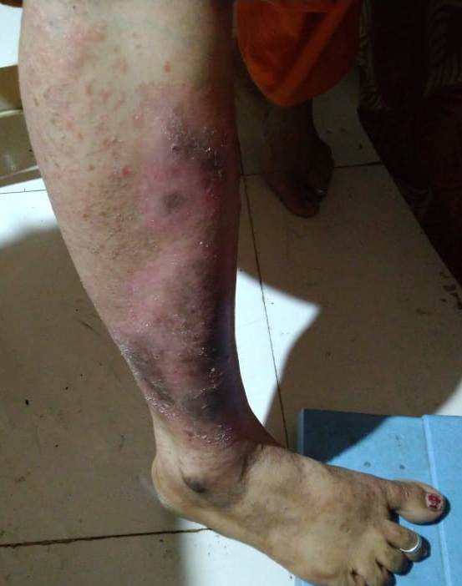 | 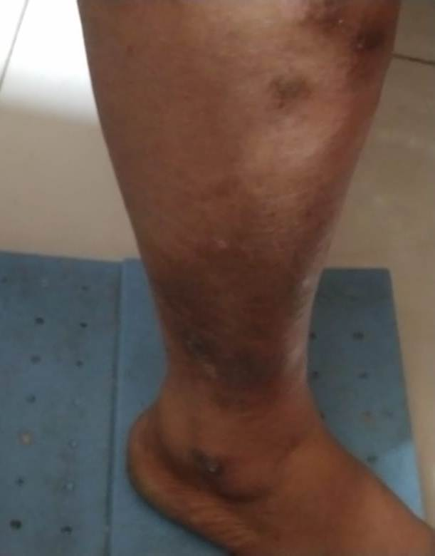 | 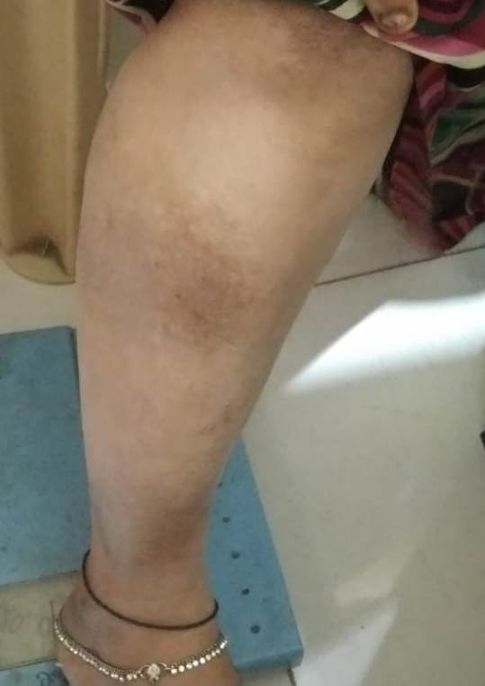
Before Treatment | During Treatment | After Treatment

References:
1. Sharma R.k.Dash B editors, Charak samhita, chikitsasthan. Ch. 7, Ver. 21, Varanasi,Chowkhamba sanskri series office2012, P.324-25
2. Menter et al. Guidelines of care for the management of psoriasis and psoriatic arthritis: Section 1. Overview of psoriasis and guidelines of care for the treatment of psoriasis with biologics. J Am Acad Dermatol2008;58(5): 826–50.
3. Acharya YT. Charaka Samhita of Agnivesha; Sutra Sthana; Atreyabhadrakapiyo Adhyay. Reprint ed. Ch. 26. Ver. 103. Varanasi; Chaukhamba Surbharati Prakashan; 2009. p 151.
4. http://www.ayursages.com/psoriasis, accessed on 23/07/2014 at 17.19. Sandeep Agrawal et al. Review of researches on Psoriasis at GAU, Jamnagar Available online at : http://ijapr.in Page 22
5. Acharya YT. Charaka Samhita of Agnivesha; Indriya Sthana; Yasyashyavanimittiya Indriyam. Reprint ed. Ch. 9. Ver. 8. Varanasi; Chaukhamba Surbharati Prakashan; 2009. p. 368.
6. Acharya Late dr. Kunte A.M., Ashtanghrudaya, Chikitsa sthana, 6thedi., Ch.19, Ver.1 , Pandurang Jawaji, Bombay;1989, p. 245
7. Sabu NR et al. The etiopathological study of Kitibha Kushtha and its principle of management by Shamana and Shodhana measures, PG Dissertation, Department of Basic Principle, IPGT & RA, Gujarat Ayurved University, Jamnagar, 1988.
8. Zala U et al. A comparative pharmaceticoclinical study of different samples of Pancha Tikta Ghrita with its effect on Eka Kushtha, PG Dissertation, Department of Rasashastra and Bhaishajya Kalpana, IPGT & RA, Gujarat Ayurved University, Jamnagar, 2004.
9. Acharya YT. Charaka Samhita of Agnivesha; Chikitsa Sthana; Kushtha Chikitshitam. Reprint ed. Ch. 7. Ver. 21. Varanasi; Chaukhamba Surbharati Prakashan; 2011. p. 451.

